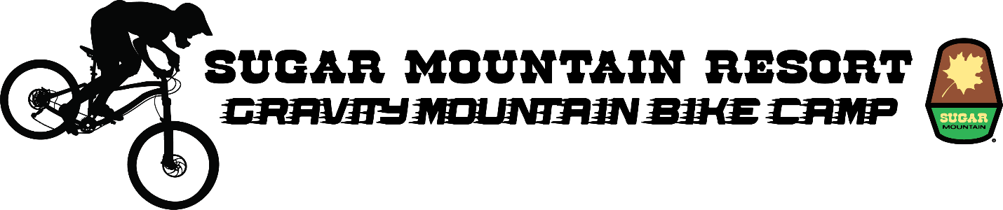Entry form

Name (print):
Address:
City: State: Zip:
Phone:
E-mail:
Age: Gender:
T-shirt size:
Parent / Guardian phone number:
Amount:
- $350 (I will bring my own mountain bike and gear)
- $429 (I need to rent a mountain bike and gear)
Payment Method
Cash Check Visa Mastercard Discover
Card Number:
Expiration Date: V-Code:
Please make checks payable to:
Sugar Mountain Resort, Inc. Gravity Mountain Bike Camp
Applications can be mailed, faxed or emailed to
Sugar Mountain Resort, Inc.
Mountain Bike Camp
P.O. Box 369
Banner Elk, NC 28604
bike@skisugar.com
828-898-6820 (fax)
For any questions, please call 828-898-4521 x 202

Waiver / Liability release
In consideration of the acceptance of my application in the Sugar Mountain Resort Gravity Mountain Bike Camp held at Sugar Mountain Resort, Inc., I hereby waive, release and discharge any and all claims for damages including, but not limited to, personal injury, death or property damage which I may incur, or which may accrue to me as a result of my participation.
This release is to discharge in advance Sugar Mountain Resort, Inc., its agents and employees from and against any and all liability out of or connected in any way with my participation in the Sugar Mountain Resort Mountain Bike Camp.
I agree to wear a full-face helmet, knee / shin pads during all training sessions and cooperate with the Sugar Mountain Resort coaching staff.
I further understand that serious accidents occasionally occur while downhill mountain biking and that mountain bikers occasionally sustain mortal and serious personal injuries and / or property damage.
Knowing the risks of downhill mountain biking, nevertheless, I hereby agree to assume those risks and to release and hold harmless the persons and entities mentioned above.
I hereby grant Sugar Mountain Resort, Inc. the right to take and utilize photographs of me participating in this activity for the purpose of promotion and advertising.

Signature of Applicant Signature of Parent / Guardian

